**Ideation Phase**

**Define the Problem Statements**

|  |  |
| --- | --- |
| Date | 3September 2022 |
| Team ID | PNT2022TMID33070 |
| Project Name | Smart Waste Management for Metropolitian Cities |
| Maximum Marks | 2 Marks |

**Customer Problem Statement Template:**

Create a problem statement to understand your customer's point of view. The Customer Problem Statement template helps you focus on what matters to create experiences people will love.

A well-articulated customer problem statement allows you and your team to find the ideal solution for the challenges your customers face. Throughout the process, you’ll also be able to empathize with your customers, which helps you better understand how they perceive your product or service.

Reference: <https://miro.com/templates/customer-problem-statement/>

**Example:**

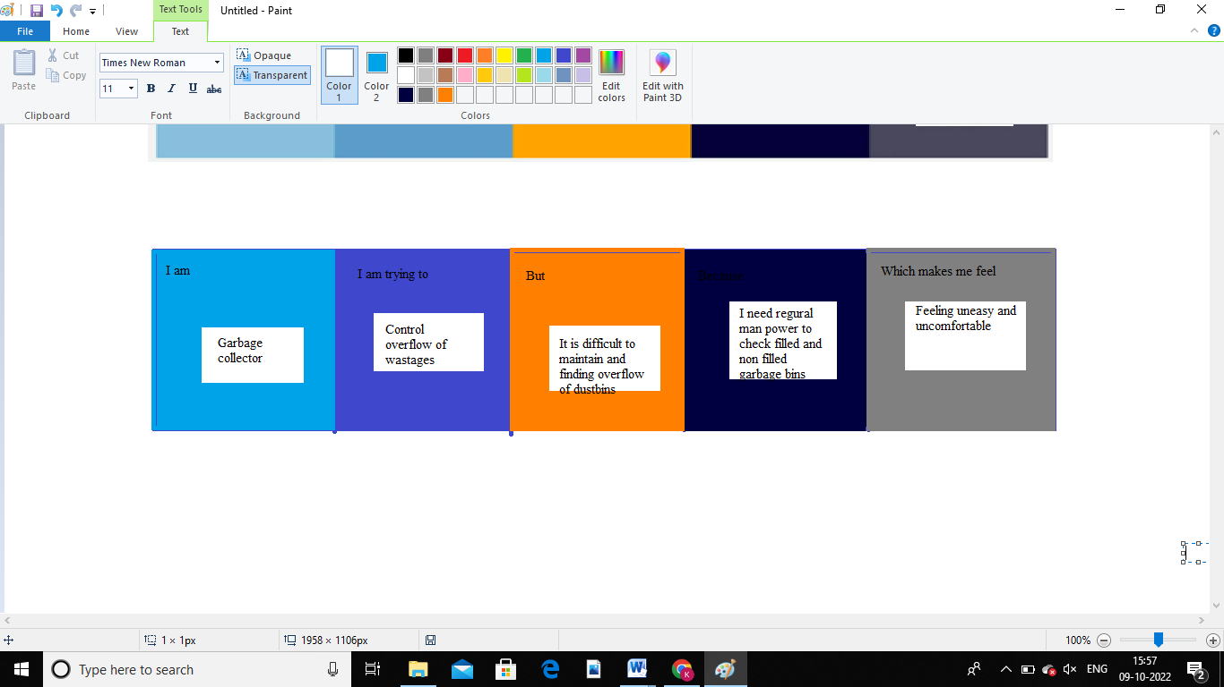

|  |  |  |  |  |  |
| --- | --- | --- | --- | --- | --- |
| **Problem Statement (PS)** | **I am (Customer)** | **I’m trying to** | **But** | **Because** | **Which makes me feel** |
| PS-1 | Garbage collector | Avoid dumping ,sensors for detecting fill level of trash | Separating degradable and non degradable is difficult,land fill cannot be easily cleaned | Separating is difficult because dumping more and more,cause bad smell,bugs and some infections. | Uncomfortable |
| PS-2 | Sanitation workers | To avoid overflow in dustbins,land fill,separation of types of waste | It is difficult to manage the dustbins which is overflowing.Checking daily whether is full or empty. | If it is full being a garbage collector it is a difficult task while taking and separating | Feeling Uneasy |